# This article is about the OT-One.

## **It's no-longer sold or actively supported by Opentrons, but we've kept this article here to help existing users. Please** [**see our OT-2 Support articles**](https://support.opentrons.com/) **for the most up to date information!**

We recommend getting started with the Protocol-O-Saurus, or the [Dinosaur Protocol](http://support.opentrons.com/getting-started/how-to-run-protocols/dinosaur-protocol). Running this protocol is a great way to familiarize yourself with your OT-One without wasting samples or reagent! The protocol instructs your robot to draw a stegosaurus on a 96 well plate (see below):

[**Download Dinosaur Protocol**](https://protocols.opentrons.com/protocol/dinosaur)

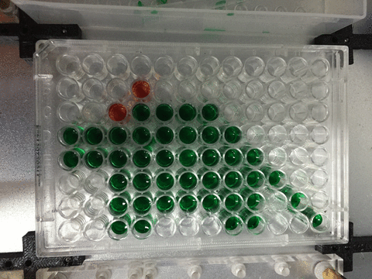

# Protocol Library

Our Protocol Library includes a variety of experimental workflows, like serial dilutions, transformations, and gene editing. You can download these protocols and run them on your robot directly, or customize them to suit your lab's needs! Click the link below to browse our protocol library:

[**Go to Protocol Library**](https://protocols.opentrons.com/)

# Writing your own custom protocols

If the protocols located in our protocol library do not fit your lab's needs, check out the [Opentrons API](http://docs.opentrons.com/) for some tips on creating your own custom protocols and python files. You can also visit our various computer support articles for more information on how to get started via the following link:

[**Computer Support Articles**](http://support.opentrons.com/computer-questions/)

As always, we're here to help at every step along the way, so please contact us with any questions!